Final Year B. Tech., Sem VII 2023-24

High Performance Computing Lab

Name: Meet Vipul Gandhi

PRN: 2020BTECS00112

Practical No. 11

1. Implement Matrix-Vector Multiplication using MPI. Use different number of processes and analyze the performance.

**Screenshots:**

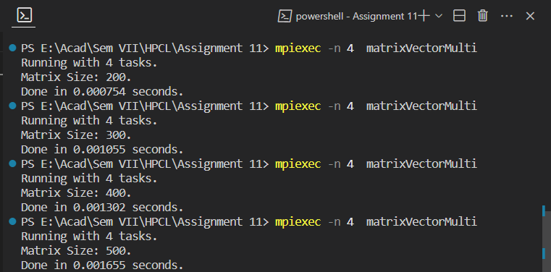

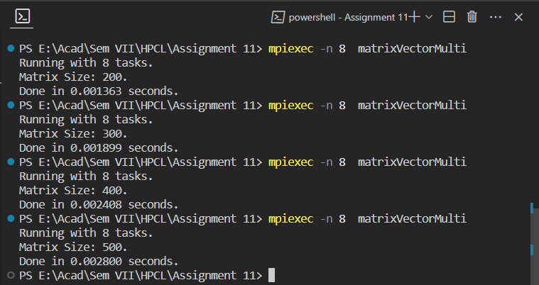

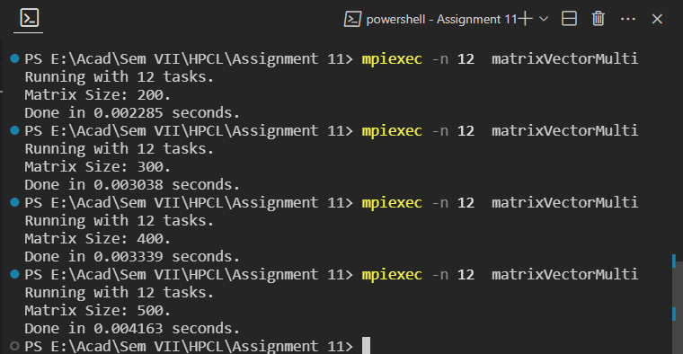

**Analysis:**

1. Implement Matrix-Matrix Multiplication using MPI. Use different number of processes and analyze the performance.

**Screenshots:**

Matrix Size: 72

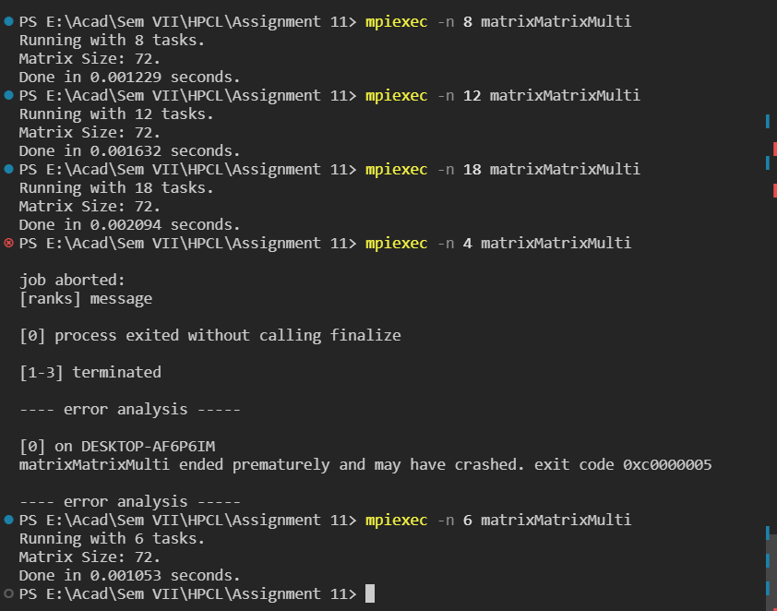

Matrix Size: 32*32

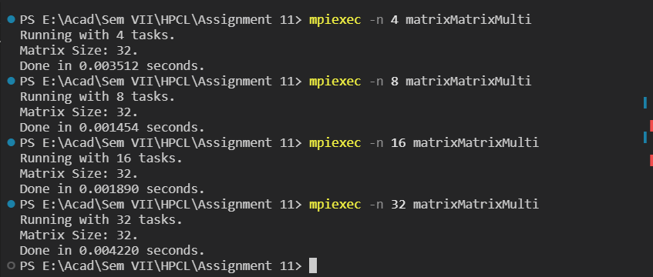

**Analysis:**



**GitHub:** <https://github.com/meetgandhi692/HPC-Lab/tree/d6ca84bab6f00d6626db7094652cc8792ecaac9a/Assignment%2011>